Shabbos Stories for
Parshas bereishis 5781
Volume 12, Issue 6 29 Tishrei/October. 17, 2020
Printed L’illuy nishmas Nechama bas R’ Noach, a”h

For a free subscription, please forward your request to keren18@juno.com
Past stories can be found on the website ShabbosStories.com

Hashem’s Berachot

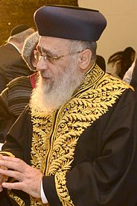
Chief Rabbi Yitzchak Yosef and Russian President Vladimir Putin

“Hashem will love you, bless and multiply you, and He will bless the fruit of your womb and the fruit of your land; your grain, your wine, your oil; the offspring of your cattle and the flocks of your sheep and goats.” The pesukim continue with an abundance of berachot for our children, our health, and our livelihood.

Just look at the Jewish population today all over the world; we are a population of just around 15 million, even after so many centuries. We are but a small fraction of one percent of the world’s population, yet we have seen beracha among our people that’s drastically disproportionate to the rest of the world. We can clearly see the fulfilment of the berachot in this week’s parasha by the disproportionate number of Jews that have achieved great things, whether in medicine, law, the humanities, technology, and so many other fields, and the tremendously high proportion of Jewish Nobel prize winners.
After only seventy years, Israel also leads the world in technology, agriculture, and so many other areas, despite the numerous disadvantages and setbacks that come from being a tiny country in a constant state of war surrounded by enemies that continuously threaten to destroy us. Let’s not fool ourselves, there’s great power in these berachot, and they only come from following in the ways of Hashem and our holy Torah!

On a Recent Trip to Russia
On a recent trip to Russia, the Sephardic Chief Rabbi of Israel, Yitzchak Yosef, met with the Russian president Vladimir Putin. The Rabbi thought it would be just a quick “photo op” type of meeting, but Putin wanted to talk with the Rabbi at length. They sat and spoke for close to ninety minutes.
Putin told the Rabbi that he considered himself a historian and had studied all of the great nations of the past — the Egyptians, the Babylonians, the Greeks and Romans, and so on. He said that it had always amazed him that the Jews have outlived all these dynasties, despite their small number and the endless persecutions that they had to endure over the centuries.
He asked Hacham Yitzchak the secret to this amazing success and perseverance. The Rabbi was about to answer Putin’s question, but President Putin decided to give his own answer. He said, “I believe the reason the Jewish people have outlasted all those other nations, is that they have always followed their Torah and because they listen to their Rabbis!”

For It Is Your Wisdom and Discernment in the Eyes of People
We can see this clearly from a passuk in last week’s parasha, Va’et-hannan, where it says “You shall safeguard and perform them [the mitzvot], for it is your wisdom and discernment in the eyes of the people, who shall hear all of these decrees and who shall say: Surely a wise and discerning people is this great nation (4:6)!”
Rabenu Bahya comments: “The Torah states that universal acknowledgement of Israel’s wisdom will result even from its adherence to the decrees — the commandments for which no reason is revealed — because the wisdom inherent in the parts of the Torah that are accessible to rational study will convince intellectually honest people that there must be great divine wisdom in the decrees as well.”

Reprinted from the Parshat Ekev 5780 email of Jack E. Rahmey as based on the Torah teachings of Rabbi Amram Sananes.
“I Didn’t Get a Fork”

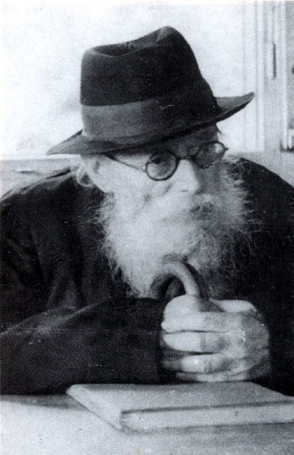

The story is told about the great Chazon Ish, Rav Avraham Yeshayahu Karelitz, zt”l, when he was a young child of only seven years old. One day when his family sat down to eat lunch together, the good smell coming from the kitchen made everyone feel hungry. After all, it wasn’t every day that they were lucky enough to have meat for lunch.
The Chazon Ish’s mother happily filled everyone’s plate, Davening that the food should give her husband and children strength to learn Torah. She passed the steaming plates of food to her family, and then sat down herself to start eating, giving a loving glance at everyone enjoying their meal.
She noticed though, that little Avraham Yeshaya’le wasn’t eating!
“Why haven’t you eaten anything yet?” she asked her son. “Do you not like how it tastes?”
“No, Imma, certainly the food tastes very good, but I didn’t get a fork.”
His mother quickly got up and brought back a fork for her child. When she reached him, she saw that she had also forgotten to serve him a plate of food! When she returned to the kitchen, she couldn’t help but smile. Her little Tzadik didn’t want to embarrass her by telling her that she forgot his lunch altogether! Instead, he waited until she realized it on her own. And even when she asked him, he said that he ‘only’ didn’t get a fork! (Chayei HaChazon Ish, p.13)

Reprinted from the Parshas Eikev 5780 email of Torah U’Tefilah as compiled by Rabbi Yehuda Winzelberg.
The Incomplete Donation

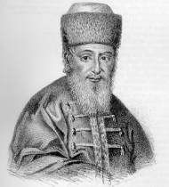

The Noda B’Yehudah, Rav Yechezkel Landau, zt”l, was once approached by two prominent leaders of the generation regarding a matter of redeeming a person who was captured in prison. They told him that in order to liberate the captive they must raise a sum of 300 gold coins.
The Noda B’Yehudah immediately went into his room and returned to them with 290 gold coins. He told them, "This is the amount I am giving you. The rest you will collect from others."
The two organizers were extremely happy to receive so much of what they were looking to collect in such a short time and thanked the Noda B’Yehudah for his help.
As they were leaving, one of them said that he had a question to ask of the Rav. "You gave us almost the entire amount that we needed to rescue the one in jail. Why wouldn’t the Rav give us the entire amount, that for the relatively smaller amount of 10 gold coins do we have to go collecting from others?"
The Noda B’Yehudah answered them, "The Mishnah in Avos (5:16) says that if one wishes to give Tzedakah but wants others not to give, then he it is considered as if he is being evil to others. It is for this reason that I specifically would like others to join in and help donate towards this worthy cause!"
(Although the Noda B’Yehudah didn't quote the entire Mishnah, the Mishnah later on says that one who gives Tzedakah and also causes others to give as well is a Chasid— a pious, righteous individual— clearly someone who the Noda B’Yehudah certainly was!)

Reprinted from the Parshas Eikev 5780 email of Torah U’Tefilah as compiled by Rabbi Yehuda Winzelberg.
Weekly Story - Our Greatness
By Rabbi Sholom DovBer Avtzon

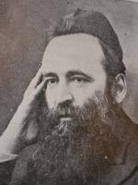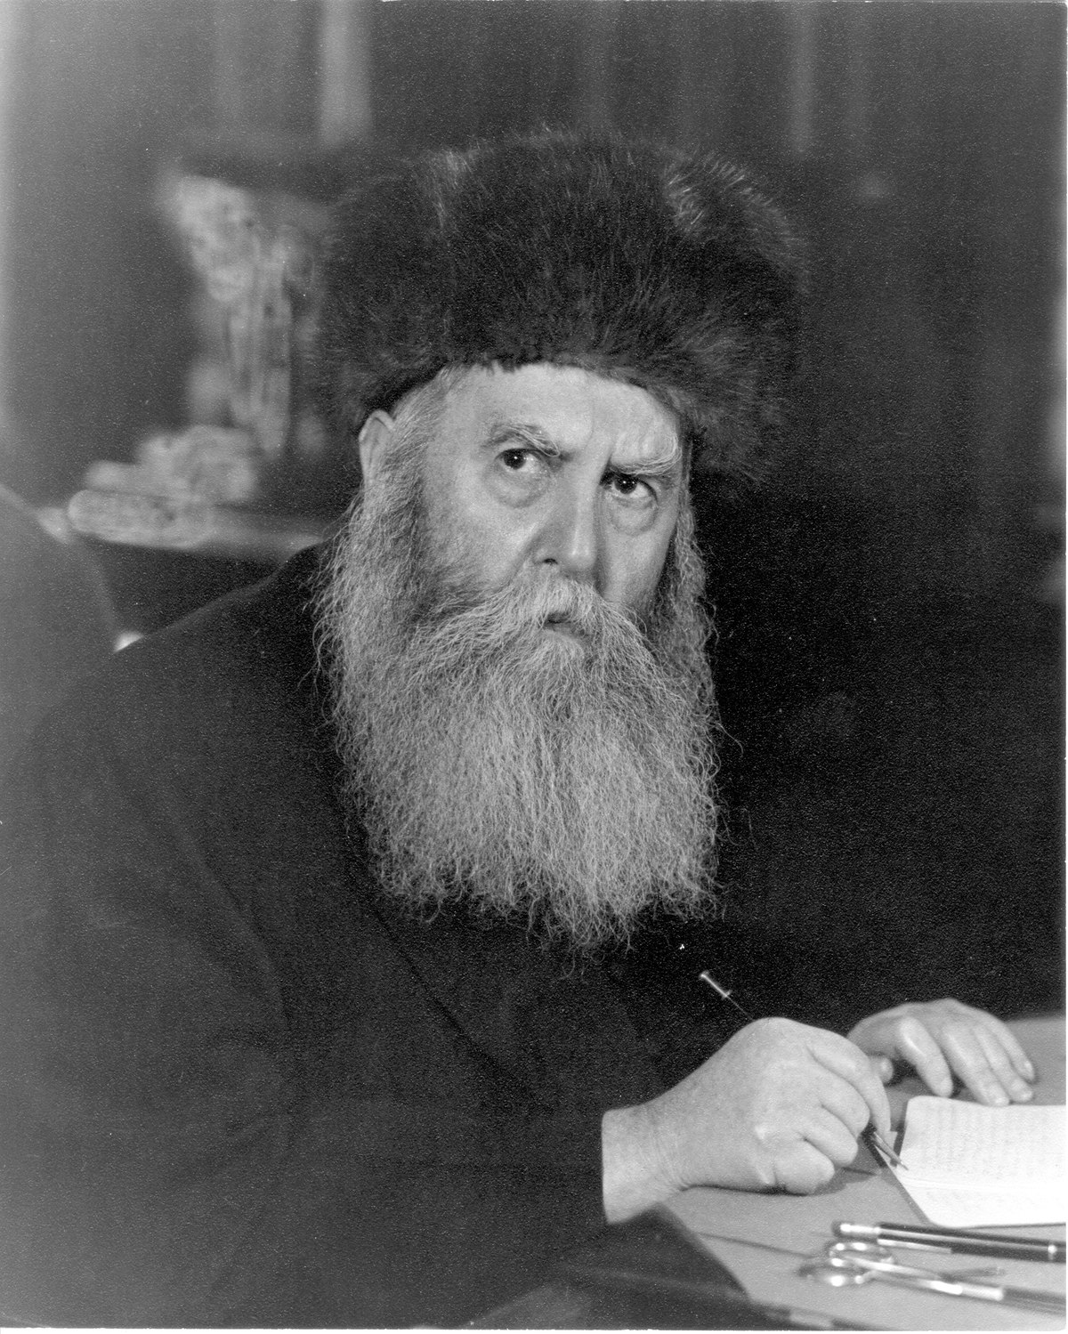
Rabbi Yechezkel Abramsky and the Frierdiker Rebbe

Recently someone asked me if I heard the following story which was related by Rabbi Eli Biderman, and I replied that I hadn’t, but I will look into it. Subsequently, I heard a few versions, so I decided to post the parts that everyone agrees on, (in the footnotes I will mention some of the differences).
Your feebback is always appreciated.

Rabbi Yechezkel Abramsky was arrested in 5689 (1929) by the communists and sentenced to five years of hard labor in Siberia. Boruch Hashem he was saved two years later and settled in England. Then in 5694 (1934) he served as the Av Beis Din of England for 17 years. He then moved to Eretz Yisroel, where he taught for another 25 years.
Once when he met the Frierdiker Rebbe (Rabbi Yosef Yitzchak Schneersohn) the Sixth Lubavitcher Rebbe), he discussed his years in Siberia. Among the points he mentioned, he related the following incident.
“One morning when I awoke and was saying Modeh Ani, I began to ponder. In my present situation which might cause me to pass on, what am I thanking Hashem for? I don’t have a siddur to daven from, I can daven only what I know by heart. I can’t put on tefillin as it was taken away from me. I can’t learn Torah as I have to work throughout the day and I have no seforim to learn from. Is this the life of a Jew?
But then I came to a realization; I am connected to Hashem and Hashem loves me just for the fact that I am a Jew. So yes, I have what to be thankful and indeed joyful about.”
The Frierdiker Rebbe said, “Reb Yechezkel, the entire [ordeal of] Siberia was worth it, to come to that realization.”
Years later when Reb Yechezkel related this encounter to his students, he gave the following preface, “My students you should know that only a tzaddik like the previous Lubavitcher Rebbe who was imprisoned by the Communists and faced the death penalty for his activities on behalf of keeping the flame of Judaism alive, could say the following answer.”
Rabbi Avtzon is a veteran mechanech and the author of numerous books on the [Lubavitcher] Rebbeim and their chassidim. He can be contacted at avtzonbooks@gmail.com If you wish to participate in it, please contact him.

Reprinted from the September 3, 2020 email of Rabbi Avtzon’s Weekly Story email.

Story #1187
“And Let Us Say, AMEN!”
From the desk of Yerachmiel Tilles
editor@ascentofsafed.com

Rabbi Mordechai Yaffe , known as ‘the Levush’ after his famous ten-volume work, was one of the foremost rabbis and Jewish leaders in Central Europe some four hundred years ago.
In 1605, at age 75, he was offered the position of chief rabbi in the important Jewish community of Posen, which he accepted on a single condition. Before starting his post he would travel to Italy and study the Torah laws of ibur chodesh, i.e. the knowledge of the lunar cycles necessary for understanding the Jewish calendar of new months and leap years, under the great Sephardic sage Rabbi Yitzchak Abuhav, in Venice.
He spent three months there until he mastered the subject. [1] Towards the end of his stay, he happened to be in the house of his teacher when a child made a blessing on a fruit. Everyone answered “Amen,” with the exception of the Levush, who unintentionally neglected to respond. The Abuhav rebuked him strongly for this omission and declared a nidoi, a personal excommunication, against Rabbi Yaffe.
For thirty days the Levush remained isolated from the rest of the community, while the ban remained in force. At the end of the period, he went to the Rabbi Yitzchak Abuhav to ask him to remove the ban. He also requested to know why his oversight had merited such a harsh punishment, as this was difficult for him to understand.

A Heavenly Death Sentence was Issued Against Him
The Abuhav said that at the moment that he had not answered amen to the child’s blessing, a heavenly death sentence was issued against him. The thirty-day ban had weakened the decree, and it could be completely overturned if the Levush and his descendants would undertake to teach the importance of responding amen to all blessings. “You Ashkenazim tend to be too negligent in this matter,” he added wryly.
He instructed the Levush that when speaking about amen he should relate the following incident, which highlights the life-or-death power of the amen response:
There was a king who despised the Jews and was always looking for an excuse to banish them from his dominion. There was only one thing that prevented him from doing so: in his kingdom was one pious Jew whom he liked and respected. This man was always successful in persuading the king to refrain from carrying out his wishes.

The Wicked Plot of the Priest
On one occasion the king was especially angry at the Jews, but once again the pious Jew subdued his wrath. A priest was present in the court at that time, and he proceeded to give the king a lengthy blessing in Latin. When he finished everyone answered “amen,” with the exception of the Jew, who was in the middle of reciting Mincha and did not understand what had been said.
The priest was furious and said that because the Jew had not answered amen, the blessing would not come to fruition. The king’s love of the Jew suddenly turned to hate, and he sentenced him to death on the spot.
Sometime after his brutal execution, the pious Jew visited a surviving acquaintance in a dream and explained what he had done to merit such a terrible end. Once a child had made a blessing on bread in his presence, but he had not answered “amen.” As a result, a heavenly decree of death had been decreed upon him, but had been held off until the incident with the king.
After the Abuhav annulled the ban against him, Rabbi Mordechai Yaffe undertook to teach the importance of saying amen for the rest of his life. Once a month he would fully recount the above incident, and he would often speak about the critical importance of responding to a blessing with amen. [2]
Indeed, until this day, the descendants of the Levush continue to bear the responsibility to tell this story. [3]

Source: Adapted by Yerachmiel Tilles from an article by Rabbi Daniel Travis at //Torah.org/learning/tefilah-life or death, and supplemented from the out-of-print book, “Let Us Say Amen,” and the book, Just One word: Halachos of Amen.
Connection: Seasonal Selichot / asking and receiving forgiveness.
Biographical notes: Rabbi Mordechai Yaffe (1530 - 3 Adar B 1612) was one of the foremost rabbis and Jewish leaders in Central Europe in his generation. An expert in Talmud, Lewish Law and Kabbalah, and also in mathematics, astronomy and other sciences, he headed the Yeshiva in Prague, where he was born, until 1561 when the Jews were expelled from Bohemia. He was known as “the Levush” because he wrote ten books which he called by the general name of Levushim (garments), and each had the word Levush in its title. (from Chabad.org)
Rabbi Yitzchak Abuhav III (b. 1520) of Venice was a noted authority on Jewish Law and author of commentaries on the Torah (not to be confused with 15th century Rabbi Yitzchak Abuhav II, after whom the famous synagogue in Safed is named and who is his grandfather, nor with the latter’s great-great-grandfather, the 13th century Rabbi Yitzchak Abuhav I, author of Menorat HaMaor).

[1] Indeed, one of his ten volumes is about the laws of Rosh Chodesh, which he titled “Levush Adar Yakar.”
[2] As cited in Kaf HaChaim 124,30
[3] Which I heard one of them do at a Melaveh Malka in Los Angeles.

Reprinted from the Parshas Netzavim-Vayeilech 5780 email of KabbalaOnline.org, a project of Ascent of Safed.

When ‘Reader’s Digest’ Proved the Existence of G-d
By Batya Schochet Lisker

My tall broad-shouldered father in his long black coat, felt hat, and salt-and-pepper beard was heading towards his car parked near the entrance of the Chabad-Lubavitch Community Center. As he fit the key into the lock of his green Pontiac, a voice startled him: “Rabbi Schochet, stop! I need to speak to you.”
My father looked up to see a man hurriedly approaching him, his short sleeved T-shirt and faded jeans no match for the frigid Canadian late fall weather. He shivered as the Arctic wind whipped at his arms and strands of dark unruly curly hair blew across his face.
“Rabbi,” the man said, scowling. “You have 10 minutes to prove to me that there is a G-d.” My father rested a sturdy hand on his shoulder and peered at him, his eyes filled with tender compassion and sagely wisdom. In a quiet voice, he told him that it would be more comfortable to have even a very short conversation indoors.
As the man settled into the leather chair on the other side of my father’s desk, he explained that he was engaged to be married to the woman of his dreams, his soulmate on every level. His family strongly opposed the marriage because she was not Jewish, and G-d does not condone such a union.
“I am going to marry her anyway,” he insisted in a confrontational and contentious manner. “The wedding is set to take place next week. I told everyone that I don’t care what they say or think. But somehow, this morning I woke up apprehensive. I decided that I must speak to a rabbi to overcome my angst. If you can prove to me categorically that there is a G-d, I will not go through with my plans. If you can’t, I will continue on my path.”

Noticed that He was Clutching the
Latest Edition of Reader’s Digest

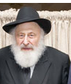
Rabbi Dovid Schochet

My father regarded him silently for a minute, noticing that he was clutching the latest edition of Reader’s Digest in one hand and had placed a shiny green apple he had brought on the desk in front of him.
“You will prove G-d’s existence to yourself,” my father said.
Taking a pocket knife from a desk drawer, my father sliced the apple in half lengthwise. Disregarding the juice dripping down his fingers, he pointed out the five stars and 10 dots inside it. “Every apple reminds us that G-d created the world—Ki bey-ah Hashem tzur olamim (Isaiah 26:4),” he said. “‘Y-ah is the name of G-d with which He created the world.’ It’s made up of two letters—yud whose numerical value is 10, and hei whose numerical value is 5.”
“That’s certainly interesting, rabbi,” the man conceded. But then he steeled himself and continued, “however, I am talking about changing my entire life and therefore your proof is not definitive enough to convince me of G-d’s existence.”
My father smiled and said, “Understandably. Open the Reader’s Digest you are holding to a page and read it to me.”
Doubtful, the man raised his eyebrows, but nevertheless did as he was told. Shaking, he read the words on the page in a trembling voice, “Shema Yisrael Ad-nai Elokeinu Ad-nai Echad—Listen, dear Jews, G-d is our G-d, G-d is one.”
He had “chanced upon” an article written by a Jewish woman comparing childhood prayers in various countries and religions. She had included the iconic Jewish prayer, six words that have been the battle cry of the Jewish people for more than 25 centuries, that her beloved grandmother had taught her.
Dumbfounded, he turned to my father with tear-filled eyes, “Our meeting today is clearly providential. There is a G-d. Thank you, Rabbi Schochet.”
I recalled my reaction when I first heard the story. “Daddy,” I said excitedly. “Wow. You performed a miracle! There is no other explanation for it.”
My father laughed and told me that I reminded him of the Chassidim’s reaction to an incident that occurred with the Tzemach Tzedek, the third Chabad Rebbe.
Two tea merchants lived in the city of Vitebsk, both named Hoisha. Big Hoisha was wealthy and ran a large, well-established, successful business. Little Hoisha’s operation was precarious at best.
One day, Little Hoisha received a message that his tea shipment had been confiscated by customs officials. He immediately collapsed to the ground in a dead faint. Every time he was revived, he remembered that he was financially ruined and passed out again.
When the Tzemach Tzedek was advised of the situation, he instructed that the next time Little Hoisha was revived, he should be told that the message was intended for Big Hoisha, not for him. And indeed, upon verification, that was exactly the case. Big Hoisha would hardly feel the loss of revenue.

The Chassidim Thought the Tzemach
Tzedek Had Performed a Miracle
The Chassidim thought they had caught the Tzemach Tzedek in the act of performing miracles. “You are mistaken,” he said. “Our sages tell us that whenever G-d gives a person a challenge in his life, He always provides him with the fortitude to withstand it. When I saw that there was no way Little Hoisha could deal with this disaster, I immediately understood that the message was not meant for him.”
“Batya’le,” my father continued. “The man was facing a tremendous challenge. I knew beyond a shadow of a doubt that G-d had already provided the means he needed to overcome it positively, it was just up to me to assist him in discovering them.”

Reprinted from the Parshat Bereishis 5781 email of Chabad.Org Magazine.

The Day After – New Spiritual Center Opens in Marrakech, Morocco

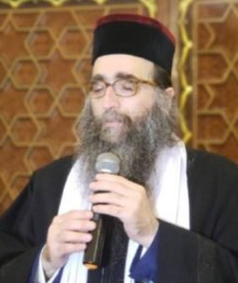

During his daily lecture, which is broadcast live to tens of thousands of viewers, Chief Rabbi of Morocco Rabbi Yoshiyahu Pinto shlit”a calls to his Jewish brothers around the world to strengthen and support Moroccan Jewry *
Rabbi Pinto announced the purchase of a giant edifice in central Marrakech that will serve as a yeshivah for young men around the world * The complex, to be named Shuva Yisrael Yeshivah Campus, shall feature an expansive beit medrash and community center that will function as a spiritual lighthouse for local Jews * Perpetuating the sacred legacy of the Torah luminaries of Maghreb
Hundreds of thousands of viewers have been following Grand Rabbi Yoshiyahu Pinto’s daily lessons and question-and-answer sessions which are broadcast live around the world and attract questions on myriad topics. During these trying times, when people worldwide are struggling with numerous crises related to the coronavirus pandemic, he has received over a thousand questions which he resolves both on an intellectual and practical level, and his responses are then aired and eagerly viewed by thousands.
Last motzaei Shabbat, Rabbi Pinto poignantly described the forlorn spiritual state of Moroccan Jewry and the vast influence that the yeshivah’s students are bringing to the local community. With pride and joy, he announced the plan to open a large yeshivah gedolah for post high-school students in Marrakech, which will be the second yeshivah to open in Morocco after the Shuva Yisrael Yeshivah opened last year in Casablanca.

Attracting Students from Israel and the United States
Shuva Yisrael Yeshiva in Casablanca has attracted students from Israel and the United States and follows the distinct Shuva Yisrael method of study. One group of students was trained as shochtim in order to avail mehadrin kosher meat to the Moroccan Jewish community.
In the beginning of last month, despite the national lockdown, Rabbi Pinto and his students received special authorization to launch a shechitah operation to ensure that local Jews would have meat and poultry in time for Pesach . Rabbi Pinto himself accepted personal responsibility to provide all disadvantaged Jewish residents of Morocco with kosher meat for the festival.
Rabbi Pinto has just announced the imminent opening of a grand yeshivah and spiritual center in Marrakech, and he is currently in the process of purchasing a beautiful, spacious edifice in the city’s center to house the yeshivah and its affiliates. Plans and specifications include renovating the building to encompass a beit medrash with 200 seats, private residences for the avreichim , and dormitory facilities for approximately 150 bachurim from countries around the world who will study in the yeshivah.

Restoring the Melodious Voice of
Torah to the City of Marrakech
He added that registration has now begun, and that he is hopeful that the country’s gates will reopen soon, allowing students to enter the yeshivah and restore the melodious voice of Torah to the city of Marrakech which was formerly a Jewish metropolis and glorious Torah center.
In the past months, following Rabbi Pinto’s mission to reinstate Torah and Judaism in Morocco, efforts were launched to locate a compound in Marrakech that would be well-suited to the new Jewish community currently being established by Shuva Yisrael. At the center of the complex, of course, would be the Shuva Yisrael Yeshivah Gedolah and residences for families who will be contributing to the burgeoning Torah presence in the city.
Gedolei Torah and eminent poskim around the world have expressed their delight upon learning of Rabbi Pinto’s vision which is slowly but surely coming to fruition. Several have even committed to visit the yeshivah on occasion to deliver shiurim to the bachurim who will be learning there.
The opportunity to dwell in the Shuva Yisrael Campus, which will house rabbis, Torah scholars and yeshivah bachurim exclusively, will be a spiritual catapult to greatness for the yeshivah’s students.

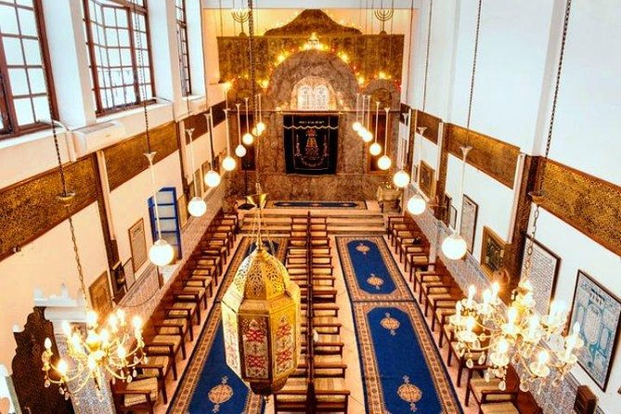
Photo of the inside of a historic synagogue in Marrakech, Morocco.

A Goal of the Yeshiva Gedolah is to
Cultivate Future Spiritual Leaders
Facilitating the personal development of students who will invest their talents and strengths into increasing Torah and mitzvah observance in the community, it will allow them to isolate themselves from material distractions and immerse themselves fully in a world of Torah and spiritual growth. One of the paramount goals of Shuva Yisrael Yeshiva Gedolah is to cultivate spiritual leaders, teachers and mentors for Moroccan Jewry and Jewish communities around the world.
The building that is currently in the process of being purchased is located in the midst of a giant campus that will provide for all the material and spiritual needs of the students. In the past weeks, the institutions have begun purchasing hundreds of sefarim to fill the shelves of an impressive Torah library that will enhance the yeshivah’s beit medrash and benefit the entire Moroccan Jewish community.
In his recent lecture, Rabbi Pinto emphasized that the development of this yeshivah is one of his foremost priorities now. He is hopeful that international air travel will resume before long and that countries around the world will reopen their gates. With the recommencement of civilian air travel, he expresses his hope that the special flights to Morocco that the yeshivah will be arranging for students will be among the very first flights to set out.

Will Spend Many Hours a Day Guiding His Students in the Yeshiva
Rabbi Pinto explained that he plans to spend many hours a day in the yeshivah, guiding his students and bequeathing them the sacred traditions and legacy of the Shuva Yisrael community, which has already inspired and imbued legions of students with the values of Torah and fear of heaven.
As noted, registration for the new yeshivah is now open. Shuva Yisrael invites bachurim and avreichim from around the world who are interested in taking part in this sacred initiative and becoming part of a yeshivah that shall restore the crown of Torah to Moroccan Jewry to register and join.

Reprinted from the Parshat Bereishit 5781 website of Hidabroot.com

